Letter of Agreement
Between
Federal Way Education Association
And
Federal Way Public Schools

The parties agree to the following:
The District will convene a committee focused on Goal 2 of the Strategic Plan during the 2018-19 school year. The Association will appoint a secondary certificated employee, an elementary certificated employee and an ESP classified employee to the committee. The committee will identify minor and major offenses as a part of PBIS implementation differentiated by level. The committee will develop a common referral process and form to be used at all schools with possible differentiation by level. The District will field test electronic referral, communication and disposition processes.

Effective September 1, 2018 through August 30, 2021.

____________________________________ ____________________
FWEA Date

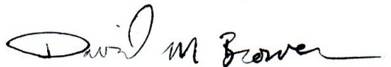
____________________________________ ____________________
For Federal Way Public Schools Date

